**What is LinqPad**  
**LinqPad**is a free tool that you can download from [http://www.linqpad.net](http://www.linqpad.net/). It helps learn, write and test linq queries.   
  
   
  
Copy and paste the following LINQ query in LinqPad. To execute the query, you can either press the **Green Execute button**on the LinqPad or press **F5**. **Dump()**method is similar to **Console.WriteLine()**in a console application.

int[] numbers = { 1, 2, 3, 4, 5, 6, 7, 8, 9, 10 };

var result = from n in numbers

                where n % 2 == 0

                orderby n descending

                select n;

result.Dump();

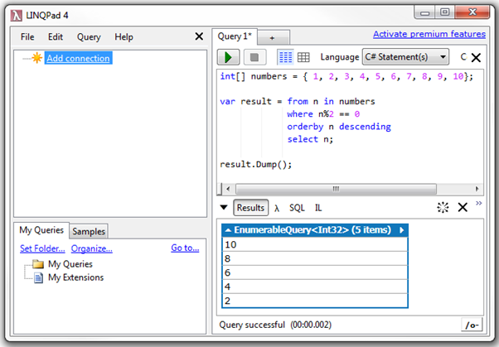  
  
Notice that the results of the query are shown in the **Results**window. Next to the results window, you also have the following options  
**1. ? (lambda Symbol) -**Use this button to get the lambda equivalent of a LINQ Query  
**2. SQL -**Shows the generated SQL statement that will be executed against the underlying database  
**3. IL -**Shows the Intermediate Language code  
  
For the above query, Lambda and SQL windows will not show anything. To get the Lambda equivalent of a LINQ query, use **.AsQueryable()**on the source collection as shown below.   
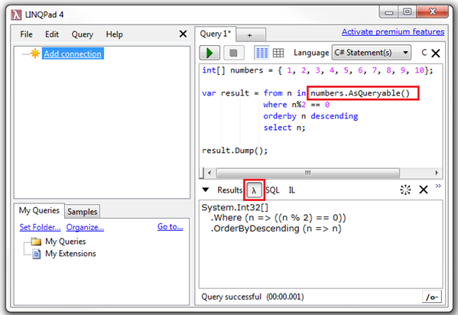  
  
**AsQueryable()** can also be used on the source collection as shown below.

var numbers = new int[] { 1, 2, 3, 4, 5, 6, 7, 8, 9, 10 }.AsQueryable();

var result = from n in numbers

                where n % 2 == 0

                orderby n descending

                select n;

result.Dump();

**LinqPad can execute**  
1. Statements  
2. Expressions  
3. Program  
  
LinqPad can also be used with databases and WCF Data Services.  
  
**Adding a database connection in LinqPad**  
**Step 1 :**Click "Add connection"  
**Step 2 :**Under LinqPad Driver, select "Default (LINQ to SQL)"  
**Step 3 :**Click Next  
  
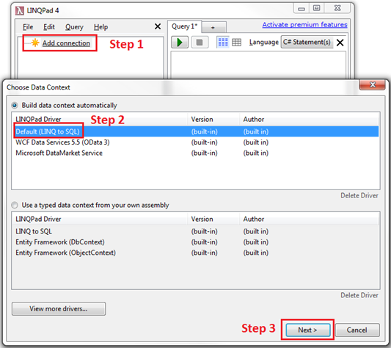   
  
**Step 4 :** Select "SQL Server" as the "Provider"  
**Step 5 :**Specify the Server Name. In my case I am connecting to the local SQL Server. So I used . (DOT)  
**Step 6 :**Select the Authentication   
**Step 7 :**Select the Database  
**Step 8 :**Click OK   
  
how to add a database connection in linqpad   
  
At this point LinqPad connects to the database, and shows all the table entities. The relationships between the entities are also shown. The Green Split arrow indicates One-to-Many relationship and the Blue Split Arrow indicates Many-to-One relationship.    
  
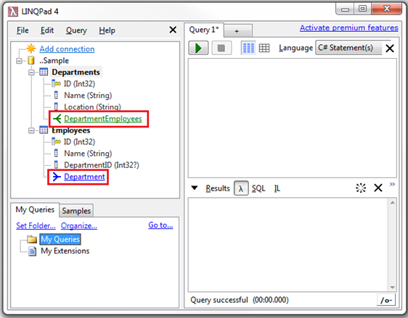   
  
We can now start writing linq queries targeting the SQL Server database.  
  
The following LINQ query fetches **all the employee names that start with letter 'M' and sorts them in descending order**  
from e in Employees  
where e.Name.StartsWith("M")  
orderby e.Name descending  
select e.Name  
  
After executing the query, click on the SQL button to see the Transact-SQL that is generated.  
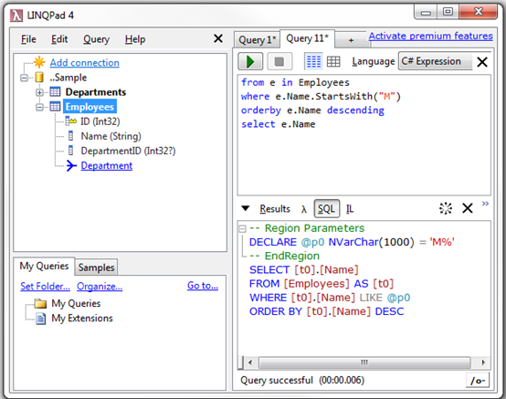   
  
**Adding a WCF Data Services connection in LinqPad**  
**Step 1 :**Click "Add connection"  
**Step 2 :**Under LinqPad Driver, select "WCF Data Services"  
**Step 3 :**Click Next   
  
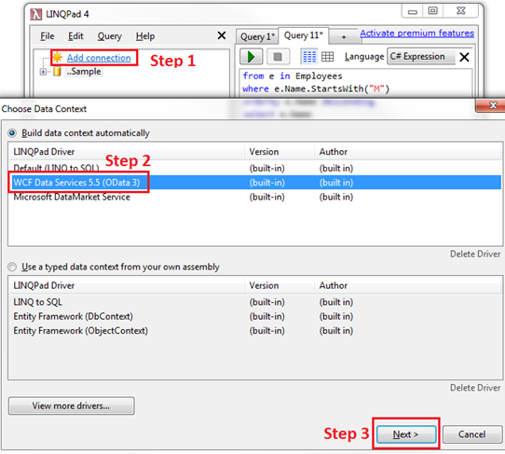   
  
**Step 4 :**Type the URI for the WCF Data Service. http://services.odata.org/V3/Northwind/Northwind.svc/  
**Step 5 :**Click OK   
  
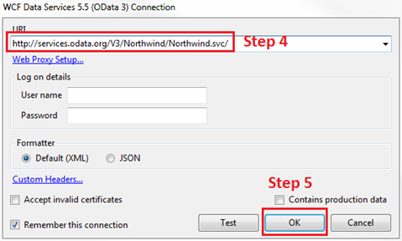   
  
We can now start writing linq queries targeting the WCF Data Service.  
  
The following LINQ query fetches **all the product names that start with letter 'C' and sorts them in ascending order**  
from p in Products  
where p.ProductName.StartsWith("C")  
orderby p.ProductName ascending  
select p